[](https://www.genmymodel.com/)

# proposed building security system

University of Liverpool

Author: ZHAOHUI LI

Date: 2022-11-03

# proposed building security system (Model)

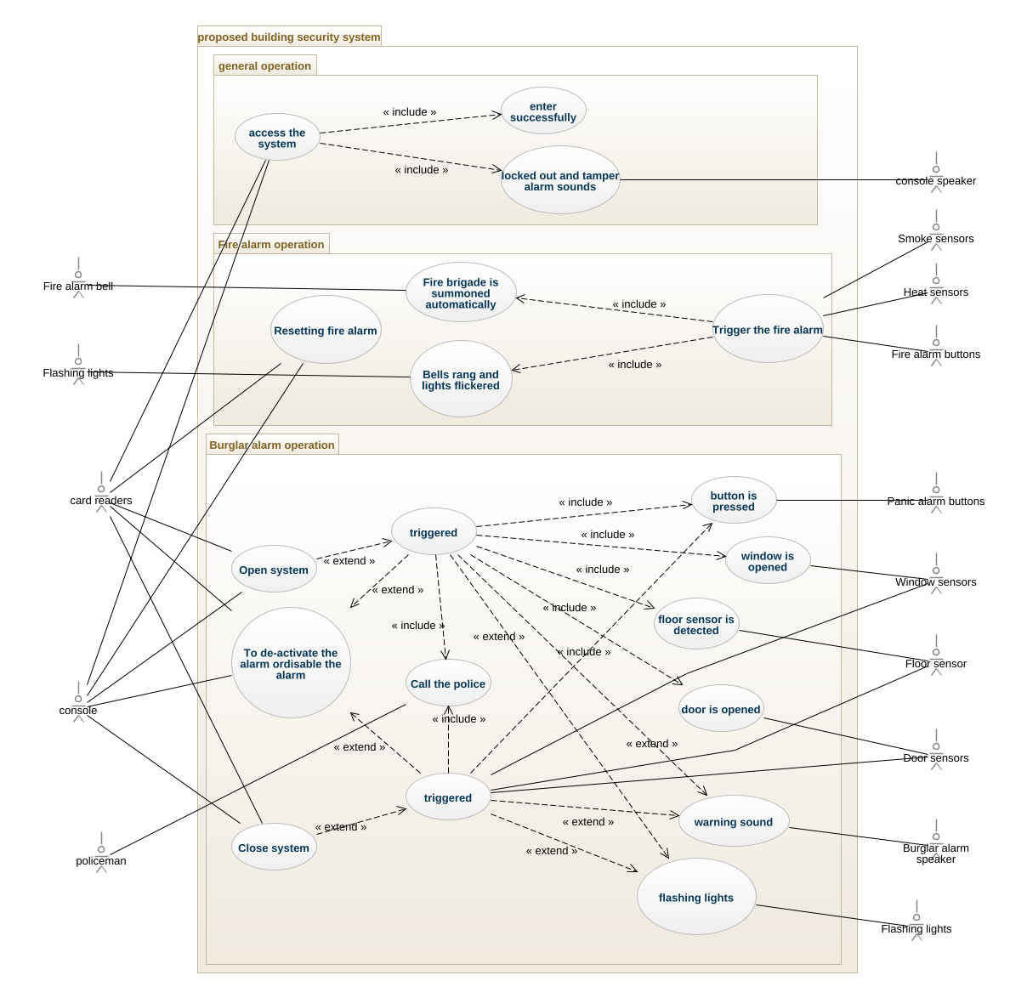

usecase-diagram

## 1. Actor3 (Actor)

In proposed building security system

## 2. Burglar alarm speaker (Actor)

In proposed building security system

| Associations |
| --- |
| warning sound_Burglar alarm speaker - warning sound : warning sound [0..1] - see definition |

## 3. Door sensors (Actor)

In proposed building security system

| Associations |
| --- |
| Door sensors_triggered - triggered : triggered [0..1] - see definition |
| door is opened_Door sensors - door is opened : door is opened [0..1] - see definition |

## 4. Fire alarm bell (Actor)

In proposed building security system

| Associations |
| --- |
| Fire alarm bell_Fire brigade is summoned automatically - fire brigade is summoned automatically : Fire brigade is summoned automatically [0..1] - see definition |

## 5. Fire alarm buttons (Actor)

In proposed building security system

| Associations |
| --- |
| Fire alarm buttons_Trigger the fire alarm - trigger the fire alarm : Trigger the fire alarm [0..1] - see definition |

## 6. Flashing lights (Actor)

In proposed building security system

| Associations |
| --- |
| Flashing lights_Bells rang and lights flickered - bells rang and lights flickered : Bells rang and lights flickered [0..1] - see definition |

## 7. Flashing lights (Actor)

In proposed building security system

| Associations |
| --- |
| flashing lights_Flashing lights - flashing lights : flashing lights [0..1] - see definition |

## 8. Floor sensor (Actor)

In proposed building security system

| Associations |
| --- |
| Floor sensor_triggered - triggered : triggered [0..1] - see definition |
| floor sensor is detected_Floor sensor - floor sensor is detected : floor sensor is detected [0..1] - see definition |

## 9. Heat sensors (Actor)

In proposed building security system

| Associations |
| --- |
| Heat sensors_Trigger the fire alarm - trigger the fire alarm : Trigger the fire alarm [0..1] - see definition |

## 10. Panic alarm buttons (Actor)

In proposed building security system

| Associations |
| --- |
| button is pressed_Panic alarm buttons - button is pressed : button is pressed [0..1] - see definition |

## 11. Smoke sensors (Actor)

In proposed building security system

| Associations |
| --- |
| Smoke sensors_Trigger the fire alarm2 - trigger the fire alarm : Trigger the fire alarm [0..1] - see definition |
| Smoke sensors_Trigger the fire alarm - trigger the fire alarm : Trigger the fire alarm [0..1] - see definition |

## 12. Window sensors (Actor)

In proposed building security system

| Associations |
| --- |
| Window sensors_triggered - triggered : triggered [0..1] - see definition |
| window is opened _Window sensors - window is opened : window is opened [0..1] - see definition |

## 13. card readers (Actor)

In proposed building security system

| Associations |
| --- |
| card readers_To de-activate the alarm ordisable the alarm - to de-activate the alarm ordisable the alarm : To de-activate the alarm ordisable the alarm [0..1] - see definition |
| card readers_Close system - close system : Close system [0..1] - see definition |
| card readers_Resetting fire alarm - resetting fire alarm : Resetting fire alarm [0..1] - see definition |
| card readers_access the system - access the system : access the system [0..1] - see definition |
| card readers_Open system - open system : Open system [0..1] - see definition |

## 14. console (Actor)

In proposed building security system

| Associations |
| --- |
| console_Close system - close system : Close system [0..1] - see definition |
| console_To de-activate the alarm ordisable the alarm - to de-activate the alarm ordisable the alarm : To de-activate the alarm ordisable the alarm [0..1] - see definition |
| console_Open system - open system : Open system [0..1] - see definition |
| console_Resetting fire alarm - resetting fire alarm : Resetting fire alarm [0..1] - see definition |
| console_access the system - access the system : access the system [0..1] - see definition |

## 15. console speaker (Actor)

In proposed building security system

| Associations |
| --- |
| locked out and tamper alarm sounds_console speaker - locked out and tamper alarm sounds : locked out and tamper alarm sounds [0..1] - see definition |

## 16. policeman (Actor)

In proposed building security system

| Associations |
| --- |
| policeman_Call the police - call the police : Call the police [0..1] - see definition |

## 17. proposed building security system (Package)

In proposed building security system

### 17.1. Burglar alarm operation (Package)

In proposed building security system::proposed building security system

#### 17.1.1. Call the police (UseCase)

In proposed building security system::proposed building security system::Burglar alarm operation

| Associations |
| --- |
| policeman_Call the police - policeman : policeman [0..1] - see definition |

#### 17.1.2. Close system (UseCase)

In proposed building security system::proposed building security system::Burglar alarm operation

| Associations |
| --- |
| card readers_Close system - card readers : card readers [0..1] - see definition |
| console_Close system - console : console [0..1] - see definition |

#### 17.1.3. Open system (UseCase)

In proposed building security system::proposed building security system::Burglar alarm operation

| Associations |
| --- |
| console_Open system - console : console [0..1] - see definition |
| card readers_Open system - card readers : card readers [0..1] - see definition |

#### 17.1.4. To de-activate the alarm ordisable the alarm (UseCase)

In proposed building security system::proposed building security system::Burglar alarm operation

| Associations |
| --- |
| card readers_To de-activate the alarm ordisable the alarm - card readers : card readers [0..1] - see definition |
| console_To de-activate the alarm ordisable the alarm - console : console [0..1] - see definition |

#### 17.1.5. button is pressed (UseCase)

In proposed building security system::proposed building security system::Burglar alarm operation

| Associations |
| --- |
| button is pressed_Panic alarm buttons - panic alarm buttons : Panic alarm buttons [0..1] - see definition |

#### 17.1.6. door is opened (UseCase)

In proposed building security system::proposed building security system::Burglar alarm operation

| Associations |
| --- |
| door is opened_Door sensors - door sensors : Door sensors [0..1] - see definition |

#### 17.1.7. flashing lights (UseCase)

In proposed building security system::proposed building security system::Burglar alarm operation

| Associations |
| --- |
| flashing lights_Flashing lights - flashing lights : Flashing lights [0..1] - see definition |

#### 17.1.8. floor sensor is detected (UseCase)

In proposed building security system::proposed building security system::Burglar alarm operation

| Associations |
| --- |
| floor sensor is detected_Floor sensor - floor sensor : Floor sensor [0..1] - see definition |

#### 17.1.9. triggered (UseCase)

In proposed building security system::proposed building security system::Burglar alarm operation

#### 17.1.10. triggered (UseCase)

In proposed building security system::proposed building security system::Burglar alarm operation

| Associations |
| --- |
| Floor sensor_triggered - floor sensor : Floor sensor [0..1] - see definition |
| Door sensors_triggered - door sensors : Door sensors [0..1] - see definition |
| Window sensors_triggered - window sensors : Window sensors [0..1] - see definition |

#### 17.1.11. warning sound (UseCase)

In proposed building security system::proposed building security system::Burglar alarm operation

| Associations |
| --- |
| warning sound_Burglar alarm speaker - burglar alarm speaker : Burglar alarm speaker [0..1] - see definition |

#### 17.1.12. window is opened (UseCase)

In proposed building security system::proposed building security system::Burglar alarm operation

| Associations |
| --- |
| window is opened _Window sensors - window sensors : Window sensors [0..1] - see definition |

### 17.2. Fire alarm operation (Package)

In proposed building security system::proposed building security system

#### 17.2.1. Bells rang and lights flickered (UseCase)

In proposed building security system::proposed building security system::Fire alarm operation

| Associations |
| --- |
| Flashing lights_Bells rang and lights flickered - flashing lights : Flashing lights [0..1] - see definition |

#### 17.2.2. Fire brigade is summoned automatically (UseCase)

In proposed building security system::proposed building security system::Fire alarm operation

| Associations |
| --- |
| Fire alarm bell_Fire brigade is summoned automatically - fire alarm bell : Fire alarm bell [0..1] - see definition |

#### 17.2.3. Resetting fire alarm (UseCase)

In proposed building security system::proposed building security system::Fire alarm operation

| Associations |
| --- |
| console_Resetting fire alarm - console : console [0..1] - see definition |
| card readers_Resetting fire alarm - card readers : card readers [0..1] - see definition |

#### 17.2.4. Trigger the fire alarm (UseCase)

In proposed building security system::proposed building security system::Fire alarm operation

| Associations |
| --- |
| Heat sensors_Trigger the fire alarm - heat sensors : Heat sensors [0..1] - see definition |
| Fire alarm buttons_Trigger the fire alarm - fire alarm buttons : Fire alarm buttons [0..1] - see definition |
| Smoke sensors_Trigger the fire alarm - smoke sensors : Smoke sensors [0..1] - see definition |
| Smoke sensors_Trigger the fire alarm2 - smoke sensors : Smoke sensors [0..1] - see definition |

### 17.3. general operation (Package)

In proposed building security system::proposed building security system

#### 17.3.1. access the system (UseCase)

In proposed building security system::proposed building security system::general operation

| Associations |
| --- |
| card readers_access the system - card readers : card readers [0..1] - see definition |
| console_access the system - console : console [0..1] - see definition |

#### 17.3.2. enter successfully (UseCase)

In proposed building security system::proposed building security system::general operation

#### 17.3.3. locked out and tamper alarm sounds (UseCase)

In proposed building security system::proposed building security system::general operation

| Associations |
| --- |
| locked out and tamper alarm sounds_console speaker - console speaker : console speaker [0..1] - see definition |